Name- Aarya Tiwari

Roll no. 16010421119

Code –

#include<iostream>

using namespace std;

int main() {

int size;

cout<<"Enter size: ";

cin>>size;

int arr[size];

int diff[size];

for(int i=0;i<size;i++)

{

cout<<"Enter element "<<i+1<<": ";

cin>>arr[i];

}

for(int j=0;j<size-1;j++)

{

diff[j] = abs(arr[j] - arr[j+1]);

}

diff[size-1] = abs(arr[size-1]-arr[0]);

int min = diff[0];

for(int k=1;k<size;k++)

{

if(diff[k]<min)

{

min = diff[k];

}

}

cout<<"The minimum difference is: "<<min<<endl;

for(int l=0;l<size;l++)

{

if(diff[l]==min)

{

cout<<"Positions are elements: "<<l+1<<" and "<<l+2<<endl;

break;

}

else if(diff[size-1]==min)

{

cout<<"Positions are elements: "<<1<<" and "<<size<<endl;

break;

}

}

return 0;

}

Output 1: Positive Numbers--

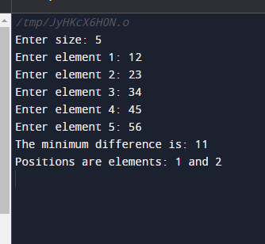

Output 2: Negative Numbers: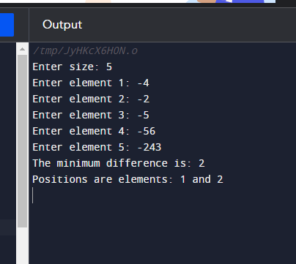

Output 3: All zero inputs—

